Which of the following is 1,4 positions?
A. Ortho
B. Para
C. Meta
D. Ipso
ANSWER: B
Which of the following is 3,5 positions?
A. Ortho
B. Para
C. Meta
D. Ipso
ANSWER: C

Which of the following is not a meta director?
A. $-C≡N$
B. $-COOH$
C. $-CF_{3}$
D. None of these
ANSWER: D
Which of the following alkyl halide will be used to prepare cumene from benzene?
A. Ethyl chloride
B. Propyl chloride
C. Hexyl chloride
D. None of these
ANSWER: B
Which of the following reagent will form maleic anhydride with benzene?
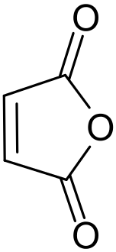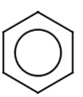
$$\underset{→}{ ? }$$
A. Oxygen in the presence of Vanadium pentoxide
B. Ozone
C. $KMnO_{4}$
D. All of these
ANSWER: A
Choose the suitable reagent to carry out this reaction.

A. Oxygen in the presence of Vanadium pentoxide
B. Ozone
C. $KMnO_{4}$
$$\underset{→}{ ? }O=CH-CH=O$$
D. All of these
ANSWER: B
To convert benzene into p-nitrobenzoic acid, following reactions are performed. The correct order should be______.
I. Alkylation II. Oxidation III. Nitration
A. I, II and III
B. III, II and I
C. I, III and II
D. II, I and III
ANSWER: C
In a reaction, phenol is added or mixed with nitric acid in presence of $H_{2}SO_{4}$. The final product is _____.
A. m-Nitrophenol
B. p-Nitrophenol
C. o-Nitrophenol
D. Both A and B
E. Both B and C
ANSWER: E
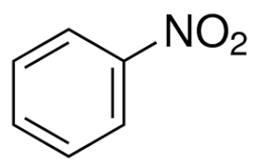
$$+HONO_{2}\begin{aligned}\underset{→}{ H_{2}SO_{4} } \\ dilute\end{aligned}$$
A. Ortho dinitrobenzene and water
B. Para dinitro benzene and water
C. Meta dinitro benzene and water
D. 2, 4, 6- trinitro benzene and water
E. None of these
ANSWER: C

Phenol reacts with concentrated nitric acid to form:
A. o-Nitrophenol
B. 2,4,6-trinitrophenol
C. Does not react with conc. Nitric acid
D. Both A and B
ANSWER: B
Which of the following alkyl halide will be used to prepare cumene from benzene?
A. Ethyl chloride
B. Propyl chloride
C. Hexyl chloride
D. None of these
ANSWER: B
Which of the following reagent will form maleic anhydride with benzene?

$$\underset{→}{ ? }$$
A. Oxygen in the presence of Vanadium pentoxide
B. Ozone
C. $KMnO_{4}$
D. All of these
ANSWER: A
Choose the suitable reagent to carry out this reaction.

A. Oxygen in the presence of Vanadium pentoxide
B. Ozone
C. $KMnO_{4}$
$$\underset{→}{ ? }O=CH-CH=O$$
D. All of these
ANSWER: B
Benzene can be converted to toluene by using
A. Friedel Craft Alkylation
B. Friedel Craft Acylation
C. Nitration
D. Oxidation
ANSWER: A
Choose the suitable reagent to carry out this reaction.
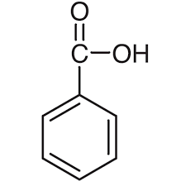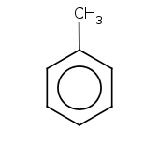
A. $KMnO_{4}/Acid$
B. $H_{2}SO_{4}$
C. $AlCl_{3}/CH_{3}COCl$
D. $H_{2}O/H_{2}SO_{4}$
ANSWER: A
$$\underset{→}{ ? }$$

